IS Thesis Design Support – Session 2
Contents
Questions Related Work 1
Where are the gaps in the literature? 1
What are the key areas of debate in the literature? 1
What are the key concepts in this area? 1
How would you categorize the kind of problem to which your research relates? 2
What is the problem statement? 2
What is the research question? 2
Is the research question related to the research gap? 2
Does the research question pursue a 3-month timeline to finish? 2
What kind of results does the research question need to be properly answered? 2
Is there a key paper that you will use as a model to format the results? 2
How will visualize your research gap in terms of a systematic overview as seen below? 3

Questions Related Work

Where are the gaps in the literature?
The literature focuses on single-image damage detection and lacks temporal, pre–post comparison methods for indoor housing inspections with picture groups, leaving no integrated approach that links visual change detection.

What are the key areas of debate in the literature?
A debate is whether single-image CNN detectors are sufficient for inspection tasks, or whether temporal, embedding-based, or similarity-learning approaches like Siamese models, foundation-model embeddings are required to handle real-world variability and inspection relevance.

What are the key concepts in this area?
Change detection, deep feature embeddings, Siamese similarity learning, heterogeneous image variability, defect classification, and inspection relevance.

How would you categorize the kind of problem to which your research relates?
This research addresses a visual change detection and similarity comparison problem under uncontrolled indoor image conditions, where viewpoint, lighting, and appearance vary significantly.

What is the problem statement?
Computer-vision systems has a difficulty to compare pre and post lease property images, preventing consistent, efficient, and objective assessment of damage, alterations, and wear for rental housing organizations due to different angles, lighting and appearance.

What is the research question?
To what extent can a Siamese model using foundation-model embeddings detect and classify inspection-relevant changes between pre- and post-lease housing images?

Is the research question related to the research gap?
Yes the RQ directly targets the missing temporal dimension, the absence of practical inspection linkage, and the gap between defect detection and actionable, inspection-oriented indicators noted in prior work.

Does the research question pursue a 3-month timeline to finish?
Yes dataset construction, embedding extraction, Siamese training, baseline comparison, and evaluation are all feasible within a 10–12 week supervised thesis cycle.

What kind of results does the research question need to be properly answered?
Quantitative performance metrics (accuracy, F1, confusion matrices, embedding-distance distributions) and qualitative evaluations of change-detection outcomes that validate whether the method supports inspection decision-making.

Is there a key paper that you will use as a model to format the results?
Kamraoui et al. (2022), which evaluates longitudinal MRI change detection using Siamese-style modeling, provides the closest methodological precedent for structuring temporal-comparison experiments.

How will visualize your research gap in terms of a systematic overview as seen below?
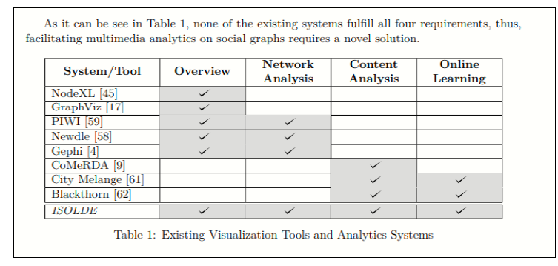
NR | Paper | Single-Image Damage Detection | Temporal Change Detection | Photo-Group Comparison | Indoor Housing Domain | Handles Heterogeneous Images | Inspection-Oriented Decision Support
1 | Cheng (Remote Sensing) | ✔ | ✔ |  |  | ✔
2 | Kang (Scan-to-BIM) | ✔ |  |  |  |  | ✔ bim workflow
3 | Sukel (Urban Issues) | ✔ |  |  |  | ✔
4 | Choi (Graffiti Detection) | ✔
5 | Chu (Stereo SR) | ✔ sr focus | ✔ stereo pair
6 | Santos Gonçalves (Indoor Doors) | ✔ |  |  | ✔ door | ✔
7 | Malla (VLM Waste) | ✔ |  |  |  | ✔
8 | Tan (Rail Transit) | ✔
9 | Kamraoui (MRI Siamese) | ✔ | ✔ Longitudinaal pairs | Partial 2 photo compare |  | ✔
10 | Shang (Pavement Cracks) | ✔
11 | Lee (Insurance Claims) | ✔ |  |  |  | ✔ | By estimation

